MAX232

MAX232:
The MAX232 is an integrated circuit that converts signals from an RS-232 serial port to signals suitable for use in TTL compatible digital logic circuits. The MAX232 is a dual driver/receiver and typically converts the RX, TX, CTS and RTS signals.
The drivers provide RS-232 voltage level outputs (approx. ± 7.5 V) from a single + 5 V supply via on-chip charge pumps and external capacitors. This makes it useful for implementing RS-232 in devices that otherwise do not need any voltages outside the 0 V to + 5 V range, as power supply design does not need to be made more complicated just for driving the RS-232 in this case.
The receivers reduce RS-232 inputs (which may be as high as ± 25 V), to standard 5 V TTL levels. These receivers have a typical threshold of 1.3 V, and a typical hysteresis of 0.5 V. The later MAX232A is backwards compatible with the original MAX232 but may operate at higher baud rates and can use smaller external capacitors – 0.1μF in place of the 1.0μF capacitors used with the original device. The newer MAX3232 is also backwards compatible, but operates at a broader voltage range, from 3 to 5.5V.
Pin Diagram of MAX232:

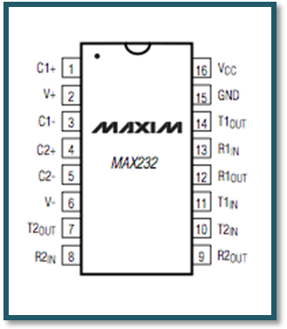

Typical Applications:

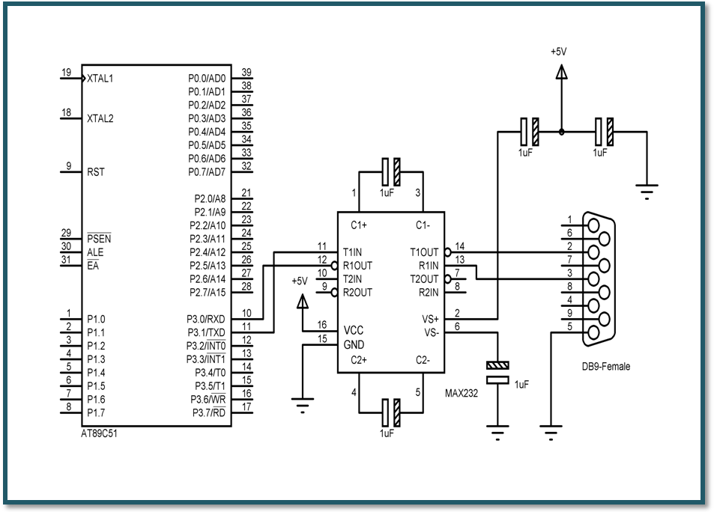

Voltage Levels:

It is helpful to understand what occurs to the voltage levels. When a MAX232 IC receives a TTL level to convert, it changes a TTL Logic 0 to between +3 and +15V, and changes TTL Logic 1 to between -3 to -15V, and vice versa for converting from RS232 to TTL. This can be confusing when you realize that the RS232 Data Transmission voltages at a certain logic state are opposite from the RS232 Control Line voltages at the same logic state. To clarify the matter, see the table below.
RS232 Line Type & Logic Level | RS232 Voltage | TTL Voltage to/from MAX232
Data Transmission (Rx/Tx) Logic 0 | +3V to +15V | 0V
Data Transmission (Rx/Tx) Logic 1 | -3V to -15V | 5V
Control Signals (RTS/CTS/DTR/DSR) Logic 0 | -3V to -15V | 5V
Control Signals (RTS/CTS/DTR/DSR) Logic 1 | +3V to +15V | 0V
The MAX232 IC is used to convert the TTL/CMOS logic levels to RS232 logic levels during serial communication of microcontrollers with PC. The controller operates at TTL logic level (0-5V) whereas the serial communication in PC works on RS232 standards (-25 V to + 25V). This makes it difficult to establish a direct link between them to communicate with each other.
The intermediate link is provided through MAX232. It is a dual driver/receiver that includes a capacitive voltage generator to supply RS232 voltage levels from a single 5V supply. Each receiver converts RS232 inputs to 5V TTL/CMOS levels. These receivers (R₁ & R₂) can accept ±30V inputs. The drivers (T₁ & T₂), also called transmitters, convert the TTL/CMOS input level into RS232 level.

The transmitters take input from controller’s serial transmission pin and send the output to RS232’s receiver. The receivers, on the other hand, take input from transmission pin of RS232 serial port and give serial output to microcontroller’s receiver pin. MAX232 needs four external capacitors whose value ranges from 1µF to 22µF.

Microcontroller | MAX232 |  | RS232
Tx | T_{1/2} In | T_{1/2} Out | Rx
Rx | R_{1/2} Out | R_{1/2} In | Tx

Pin Diagram:
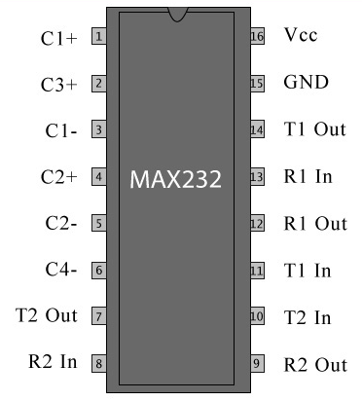
Pin Description:

Pin No | Function | Name
1 | Capacitor connection pins | Capacitor 1 +
2 | Capacitor connection pins | Capacitor 3 +
3 | Capacitor connection pins | Capacitor 1 -
4 | Capacitor connection pins | Capacitor 2 +
5 | Capacitor connection pins | Capacitor 2 -
6 | Capacitor connection pins | Capacitor 4 -
7 | Output pin; outputs the serially transmitted data at RS232 logic level; connected to receiver pin of PC serial port | T₂ Out
8 | Input pin; receives serially transmitted data at RS 232 logic level; connected to transmitter pin of PC serial port | R₂ In
9 | Output pin; outputs the serially transmitted data at TTL logic level; connected to receiver pin of controller. | R₂ Out
10 | Input pins; receive the serial data at TTL logic level; connected to serial transmitter pin of controller. | T₂ In
11 |  | T₁ In
12 | Output pin; outputs the serially transmitted data at TTL logic level; connected to receiver pin of controller. | R₁ Out
13 | Input pin; receives serially transmitted data at RS 232 logic level; connected to transmitter pin of PC serial port | R₁ In
14 | Output pin; outputs the serially transmitted data at RS232 logic level; connected to receiver pin of PC serial port | T₁ Out
15 | Ground (0V) | Ground
16 | Supply voltage; 5V (4.5V – 5.5V) | Vcc

